3GPP TSG RAN WG1 #125 R1-2603605
Dalian, China, May. 18th ~ 22nd, 2026

Agenda Item: 10.8.2
Source: Spreadtrum, UNISOC
Title: Discussion on aspects of integration of sensing with communication
Document for: Discussion and decision

Introduction
Based on the guidance from RAN1#124bis FL summary [1], we present our views on aspects of integration of sensing with communication for 6GR ISAC.

Plan for RAN1 #125
Based on the agreements made in RAN1#124bis, let’s parallelly identify other issues for study and elaborate the study on RS design and measurement/report. Note: Since we are in study phase, please focus on key design choices with proper justification.
- Usage scenarios for sensing assisted communication.
Note: this doesn’t mean we want to directly specify anything. We need RAN1 views on communication assistance which is required by RAN. To justify a usage scenario, either evaluation (10.8.1) or analysis can be considered.
Note: after clarification on the usage scenarios, it is possible that they are merged with object detection/tracking in respective discussions.
- RS design
  - Please elaborate designs on sensing RS especially the RE patterns.
  - Please provide evaluations/analysis.
- Measurement/report
  - Measurement definitions/levels for TRP-side and UE-side measurements, taking into account the impact of non-ideal factors.
  - Views on key issues of measurement reporting mechanisms.
- Based on discussions in this meeting (though no agreements yet), the inputs on the following aspects can be considered which is up to each company.
  - Resource allocation/multiplexing
  - Phase continuity within a CPI
  - Beam related sensing operations
  - Interference handling
  - Power control
  - Timing advance
  - Sensing Tx/Rx node selection, if any, from RAN1 perspective
  - Start/end/activation/deactivation of sensing operations, if any, from RAN1 perspective

Discussion

Sensing RS generation
The following agreement about sensing RS is made in RAN1 124 bis [1]:
Agreement:
- On RS for ISAC, study at least the following aspects, considering sensing performance, resource overhead and impact to communication
  - RS for communication is reused for sensing
  - Enhanced RS for sensing, taking reuse of RS for communication as starting point
    - Note: Part of or all of the RS may be used for communication purpose, and it does not mean the final decision on whether the enhanced RS is used for communication purpose is to be made in this agenda.
  - Dedicated RS for sensing
Agreement:
- Study RE patterns of RS for sensing, considering sensing performance, resource overhead and impact to communication
- Note: enhancements on RS sequence if any will be discussed in agenda 10.8.3

2.1.1 Reusing RS for communication for sensing
When reusing communication reference signals (RS) for sensing, it is important to consider the fundamental trade-off between sensing performance and resource efficiency. To simultaneously achieve high range and velocity estimation accuracy, as well as large estimation range, the sensing RS pattern generally needs to occupy a significant amount of time-frequency resources.
To address this trade-off and reduce resource overhead while maintaining high sensing performance, the sensing RS pattern can be designed in a non-uniform manner. For example, for range estimation, a small number of OFDM symbols with wide frequency-domain bandwidth can be allocated, whereas for velocity estimation, a larger number of symbols with reduced bandwidth per symbol can be used to extend the time-domain observation window. Such asymmetric time-frequency allocation enables more efficient utilization of resources while preserving sensing capability.
The figure below gives some examples on the RE pattern configuration. The combined resources can independently configure their own time and frequency domain behaviors, including duration, bandwidth and time and frequency domain combs. Within each example, the part with larger bandwidth is used for range estimation, and the part with longer duration is used for velocity estimation.

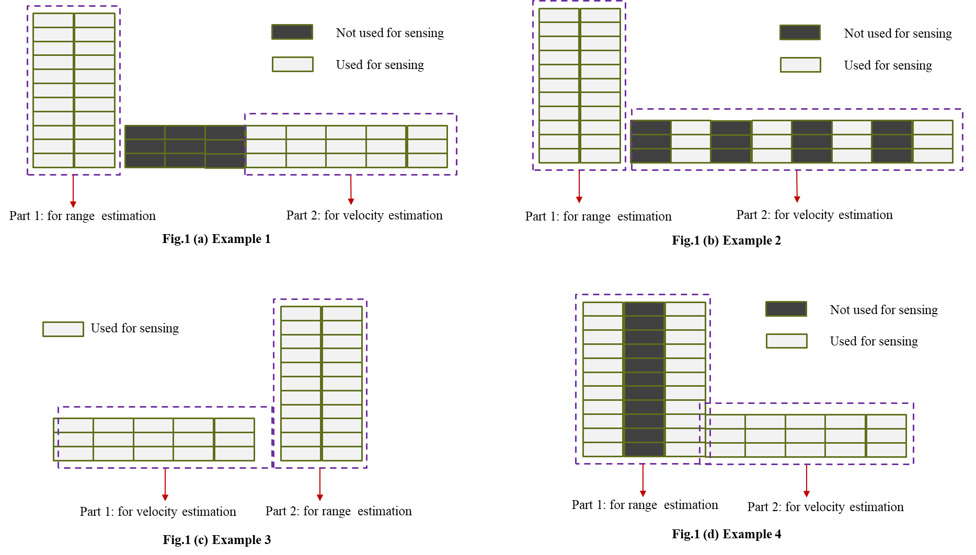
Fig.1 Demonstration on non-uniform RE pattern by using different RS resources
Based on existing RS frameworks, this flexible sensing pattern can be realized by configuring multiple sensing resources, where each individual resource follows a regular structure, but the overall combination of these resources forms a non-regular sensing pattern. This approach allows reusing existing RS designs with minimal modification, while still supporting more advanced sensing requirements.
The combination can involve both RSs of the same type, e.g., multiple CSI-RS resources, and RSs of different types, e.g., combining DMRS and PTRS, where DMRS has a larger bandwidth and PTRS has longer duration.
Proposal 1: For reusing RS for communication, study non-uniform RE patterns by combining multiple RS resources including the same and/or different type RS for communication.
In the previous meeting, it was clarified that the reference signal discussion in this section mainly refers to the RE pattern, i.e., the allocation of REs in time, frequency, and spatial domains, without explicitly covering the sequence.
This leaves an open question: when reusing communication RS for sensing, should we reuse only the RE pattern, or both the RE pattern and the associated sequence?
Our view is that both the RE pattern and the sequence should be reused together. The rationale is as follows. The sensing performance depends not only on RE placement but also critically on the sequence characteristics. Reusing only the RE pattern while modifying the sequence may break the designed orthogonality, degrade channel estimation consistency, and introduce additional implementation complexity. Joint reuse of RE pattern and sequence ensures alignment with existing transmitter/receiver designs, preserves signal properties, and enables reliable sensing without redefining the full signal structure.
Proposal 2: The reuse of existing 6GR RS for communication includes both RE patterns and sequence design.

2.1.2 Enhanced RS for sensing
The maximum unambiguous range is achieved only when the comb offset number equals one. However, if two co-prime comb setups are used to estimate the range separately and the results are then combined, an equivalent maximum unambiguous range corresponding to a single comb offset can be obtained.
Similarly, in the time domain, if sensing resources are configured with co-prime comb structures (e.g., co-prime symbol spacings or repetition intervals), the Doppler (velocity) can be estimated separately under each configuration. By jointly processing these estimates, an equivalent maximum unambiguous velocity corresponding to a comb offset of one can be obtained. This approach effectively extends the unambiguous Doppler range without requiring dense time-domain sampling, thereby improving efficiency while maintaining high sensing performance.
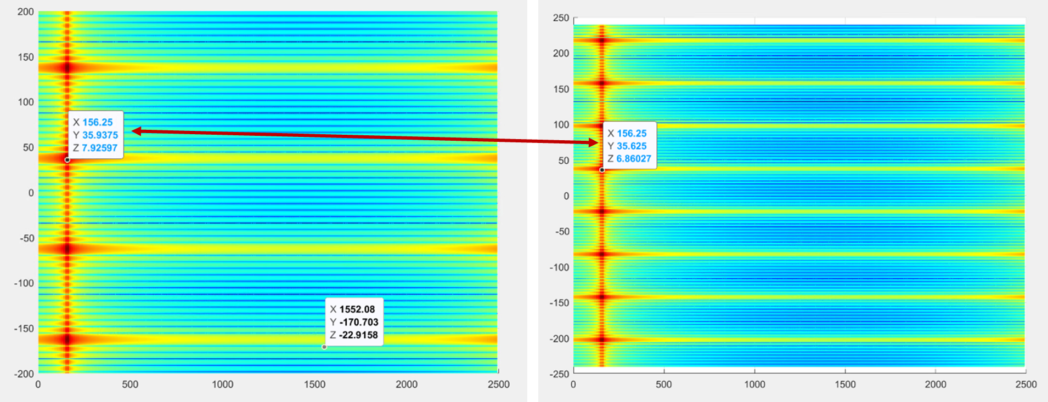
Fig.2 Demonstration of joint estimation of velocity applying coprime comb configurations
The figure above illustrates the use of co-prime time-domain comb configurations (comb-3 and comb-5) to extend the maximum unambiguous velocity. Each configuration individually produces multiple ambiguous velocity estimates due to periodicity. However, since the two comb spacings are co-prime, their ambiguous candidates only overlap at a single point within the observation window. This unique intersection corresponds to the true target velocity, achieving an effective unambiguous velocity range equivalent to a comb-1 configuration.
A key benefit of this type of configuration is reduced resource overhead. By combining sensing resources with different time-domain comb densities, a flexible trade-off between performance and resource usage can be achieved. Specifically, high-density resources (e.g., comb1) can be configured with short duration or limited bandwidth to provide a large unambiguous range with minimal resource usage. In contrast, low-density resources (e.g., comb3, comb5, comb7) can span longer durations or larger bandwidths to improve delay or velocity estimation accuracy, while still maintaining low overhead due to their sparse structure.
By jointly using these resources, the overall configuration can achieve similar unambiguous range and resolution performance as the baseline (i.e., continuous comb1 over full duration/bandwidth), but with significantly reduced overhead.
As illustrated in the figure below, two example cases are provided. In Case 1, a combination of comb1 with short duration and comb3 with longer duration is applied, which reduces overhead compared to the baseline shown on the top. In Case 2, the configuration is further extended by combining three co-prime comb sizes (comb3, comb5, and comb7), demonstrating a more flexible design that maintains performance while further optimizing resource usage.
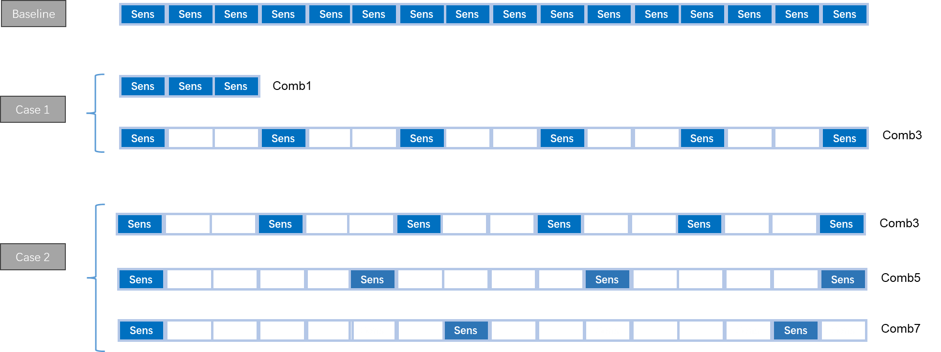
Fig.3 Examples of co-prime time-domain comb configurations
Proposal 3: For enhanced RS for sensing, study coprime comb configurations for both time and frequency domains to obtain high velocity and distance estimation range while reducing overhead.

2.1.3 Dedicated RS for sensing
One key feature of the dedicated RS for sensing should be cross-slot resource configuration. Enabling cross-slot configuration for sensing reference signals brings clear advantages:
Improved range estimation accuracy
In legacy NR design, a reference signal resource is confined within one slot, limiting the time-domain observation window. With cross-slot configuration, The sensing signal can span multiple consecutive slots to effectively increase the CPI, bringing about Narrower autocorrelation peak to improve ranging accuracy.
Improved doppler resolution and velocity estimation
Velocity estimation depends on the observation duration in time. And Cross-slot transmission the total observation window and enable finer Doppler resolution. This leads to more accurate velocity estimation and better detection of slow-moving targets.
Higher energy accumulation for better detection SNR
Sensing echo signal is typically with low energy due to high path loss. When signals are spread across multiple slots total transmitted energy per sensing instance increases, and aNB can perform coherent or non-coherent combining to increase receiving SNR. This directly leads to higher detection probability.
Reduced sensitivity to slot-level scheduling constraints
Conventional slot-bound scheduling introduces fragmentation issues for sensing. If sensing RS is restricted within a single slot, independent RS configurations are required per slot, with each slot separately scheduled and activated. This may result in increased scheduling overhead, higher system and standardization complexity, and broken phase continuity. Cross-slot configuration can naturally address these issues.
Proposal 4: For dedicated RS for sensing, study cross-slot design.

2.2 Sensing assist communication
Sensing assist communication may start from either or both of the following two cases:
- CSI acquisition and prediction
Sensing can assist CSI acquisition and prediction by providing additional environmental awareness beyond conventional pilot-based estimation. By leveraging sensing information such as target location, movement, and surrounding scatterers, the network can better understand channel dynamics and evolution. This enables more accurate CSI prediction, reduces the reliance on frequent reference signal transmission, and improves channel estimation robustness, especially in high-mobility or rapidly changing environments.
- Beam management
Sensing can enhance beam management by offering direct spatial information about users and surrounding objects. Instead of relying solely on beam sweeping and measurement, sensing can provide prior knowledge of user direction and blockage conditions. This allows faster beam alignment, reduced beam search overhead, and improved beam tracking performance. In dynamic scenarios, sensing can also help predict beam changes, enabling proactive beam switching and maintaining link reliability.
The premise of these use cases is the Sensing information acquisition. From our perspective, sensing information acquisition can be categorized into two modes: with UE involvement and without UE involvement. In the former case, UE participates in sensing and therefore measurement reporting is required, while in the latter case sensing is performed solely at the network side without UE feedback.
when UE involvement is considered, the reported sensing information should focus on parameters that directly support communication optimization. Specifically, for CSI-related enhancement, reporting of delay, Doppler, and possibly angle-related measurements is beneficial to capture channel dynamics. For beam management, reporting of angle-related information and dominant path characteristics is most relevant, enabling faster beam alignment and tracking. Higher-level abstraction (e.g., full object-level information as in Level D) may not always be necessary and should depend on UE capability.
Proposal 5: Both CSI acquisition & prediction and beam management can be adopted as the initial usage scenarios for sensing assisted communication.
- FFS: the corresponding measurement quantities

2.3 Measurement and report
The following agreement about sensing measurement and report is made in RAN1 124 bis [1]:
Agreement:
- On measurement for ISAC, study at least the following aspects.
  - Measurement definitions/levels for TRP-side measurement, taking the measurement Levels studied in NR ISAC as starting point
  - Measurement definitions/levels for UE-side measurement
  - Impacts of non-ideal factors on measurement
  - Other aspects are not precluded
  - Note: this discussion may or may not mean there is specification impact

Agreement:
- On measurement report for ISAC, study at least the following aspects and applicable scenarios (e.g., sensing modes, targets, etc.) from RAN1 perspective.
  - Measurement reporting mechanism from UE
    - Option 1A: The UE measurements and/or assistance information if needed from UE can be directly sent to aNB
    - Option 1B: The UE measurements and/or assistance information if needed from UE can be sent to SF
  - Measurement reporting mechanism from aNB
    - Option 2A: The aNB measurements and/or assistance information if needed from aNB can be directly sent to UE
    - Option 2B: The aNB measurements and/or assistance information if needed from aNB can be sent to SF
  - The study may require cross-WG coordination.
  - Note: combination of multiple options is not precluded.
  - Note: measurements in each option may be different

Agreement:
- On measurement report for ISAC, study impacts from at least the following aspects from RAN1 perspective
  - Measurement reporting mechanism
    - E.g., Periodic, semi-persistent, aperiodic, event-triggered report as starting point
    - Reporting signaling e.g., L1, L2, higher layer, etc.
  - Other aspects are not precluded
  - The study may require cross-WG coordination.

2.3.1 TRP-side measurement
For TRP-side sensing measurement, while the information is transmitted via the core network, it is reasonable to deprioritize Level A. Although Level A provides raw sensing data with high flexibility, it results in a significantly large data volume due to the transmission of low-level signal information (e.g., IQ samples or raw observations). Such data volume may lead to excessive burden on transport networks, increased latency, and reduced efficiency in practical deployments. Compared to higher-level abstractions, Level A lacks scalability and is less suitable for standardized solutions. Therefore, Level A is considered less favorable and should be deprioritized for TRP-side sensing measurement.

2.3.2 UE-side measurement
For UE-side sensing measurement, it is beneficial to reuse the existing Level A to Level D framework defined for TRP-side measurement. This unified definition provides a consistent abstraction of sensing information across different reporting entities, which helps avoid redundant or fragmented specifications.
Furthermore, performing down-selection based on this common framework helps identify practical and feasible solutions for UE-side implementation.

2.3.2.1 Down selection of measurement Levels
When considering sensing measurement from UE side, the applicability of the agreed Level A–D framework needs to be re-evaluated.
- Level A (raw/sample-level data) is not suitable for uplink reporting due to the extremely large payload size, and is therefore excluded.
- Level B (profile-level data) still introduces significant overhead, although it can be seen as a compressed form of Level A.
UE uplink reporting should primarily focus on Level C and Level D. These levels provide a better trade-off between reporting overhead and semantic value of the sensing information. Level B can also be a potential option.
Here, some down selection discussion on Level C and Level D are presented.

2.3.2.2 Down selection of Options within Level C
For Level C, the figure below is used to demonstrate the main significance of each suboptions.
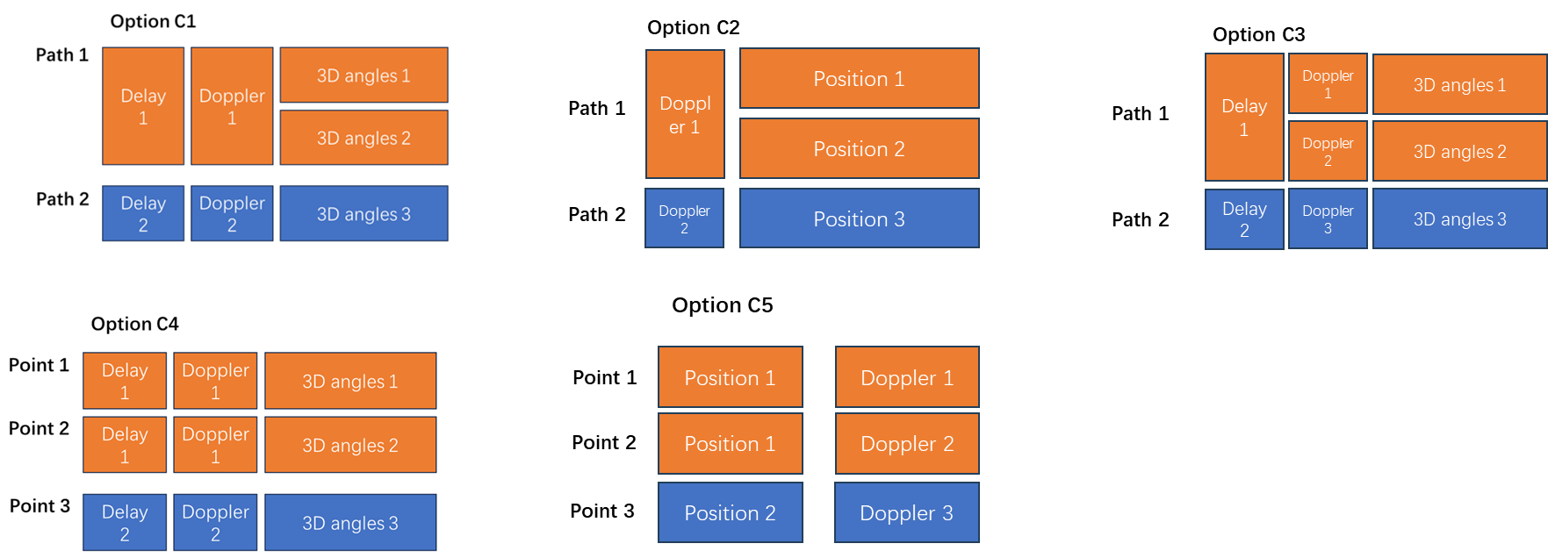
Fig.4 Demonstrations of suboptions of Level C
From our view, it is reasonable to prioritize Options C4 and C5. A key consideration is that several other Level C options implicitly require the UE to perform advanced target-level interpretation by recognizing ambiguities. However, whether the UE is capable of reliably performing such high-level sensing inference remains questionable. Compared to the aNB, the UE is typically constrained in terms of processing capability, antenna configuration, and power consumption, which limits its ability to perform robust angle estimation or ambiguity resolution, especially in challenging propagation environments (e.g., rich multipath or NLOS conditions).

2.3.2.3 Down selection of Options within Level D
For Level D, the figure below is used to demonstrate the main significance of each suboptions.
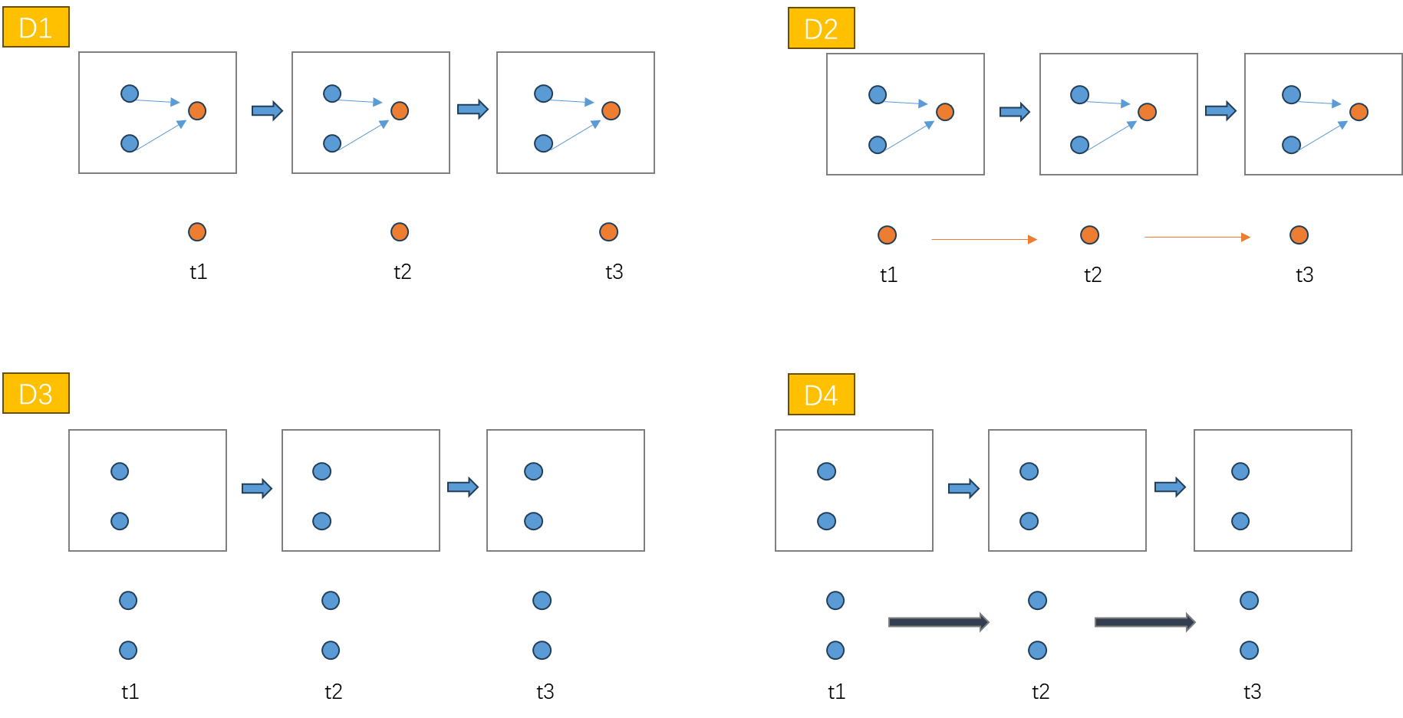
Fig.5 Demonstrations of suboptions of Level D
Based on our view, it is reasonable to deprioritize Options D1 and D2. A key consideration is the complexity associated with object-level semantic inference at the UE side. In particular, Options D1 and D2 implicitly require the UE to simultaneously identify and track multiple reflection points associated with a single physical target, and further to associate these points as belonging to the same object. This involves advanced processing such as multi-point clustering, trajectory consistency checking, and object-level data association, which are highly sensitive to channel conditions and measurement uncertainty.
However, such capabilities may pose a significant challenge for the UE. Due to limitations in processing capability, antenna configuration, and sensing aperture, the UE may not be able to reliably distinguish whether multiple detected points originate from the same target, especially in environments with rich multipath or closely spaced objects. Incorrect association at this stage may lead to erroneous semantic interpretation, which is difficult to correct at higher layers.
In contrast, Options D3 and D4 avoid requiring the UE to perform complex multi-point association and object reconstruction. Instead, they allow the UE to provide sensing-related information in a more abstracted or loosely interpreted manner, without enforcing strict object-level consistency.
It is further reasonable to prioritize Option D3 over Option D4. The main consideration lies in the additional complexity introduced by temporal tracking and trajectory-level interpretation in Option D4. Specifically, D4 requires the UE not only to detect and interpret sensing-related information at a given time instance, but also to continuously track targets over time and derive trajectory-level information. This involves maintaining temporal consistency, handling target appearance/disappearance, and performing reliable tracking under dynamic channel conditions.
Such requirements may pose significant challenges for the UE. In particular, for handheld UEs, the sensing geometry is inherently unstable due to user mobility, device orientation changes, and limited antenna aperture. These factors make it difficult for the UE to maintain consistent observations over time and to reliably perform trajectory estimation. As a result, tracking performance at the UE side may be highly unreliable and implementation-dependent.
In contrast, Option D3 focuses on more instantaneous or loosely interpreted semantic information without requiring long-term tracking or trajectory reconstruction. This significantly reduces UE complexity and avoids the need for maintaining temporal state and performing continuous data association. Furthermore, trajectory-level processing can be more effectively handled at the network side, where observations from multiple UEs and sensing nodes can be aggregated to achieve more robust and accurate tracking.
Therefore, prioritizing D3 over D4 is aligned with the principle of minimizing UE-side complexity while ensuring robustness and feasibility of sensing reporting, especially for practical UE types such as handheld devices.

2.3.2.4 Other considerations about Level C and Level D
Regarding Level C and Level D, some issues need further discussion.
Firstly, a key difference between Level C and Level D is that Level C may include both target-related reflections and environmental scatterers, while Level D assumes that irrelevant environmental components are removed, and only target-related information is reported. This assumption is reasonable for network-side sensing (e.g., multi-TRP processing), but may not hold for UE-based sensing. From a UE perspective, the available mechanisms for such discrimination are limited. In practice:
- Doppler information may be the primary feature to distinguish moving targets from static clutter
- static or slow-moving objects remain difficult to classify
UE lacks multi-TRP diversity and large-scale spatial processing capability. From our perspective, only information UE can use for environment recognition is doppler.
Secondly, We also have consideration of UE-local LCS information reporting. How UE-local LCS (Location Information) can be reported to aNB-side GCS? Key questions include:
- Whether the UE physical layer has access to LCS information, e.g. GNSS (GPS) module or local gyroscope, and other positioning subsystems.
- whether such information should be:
  - obtained and managed at higher layers
  - obtained and managed at layer 1.
At last, we discuss the velocity reporting dimension. RAN1 should clarify whether velocity should be limited to 2D (radial or planar), rather than full 3D velocity.

2.3.3 Summary
Proposal 6: For definitions/levels for 6GR ISAC TRP-side measurements, Level B, Level C and Level D from TR 38.765 Section 5.1 “Definitions of Levels/Options” can be used as the starting point.
Proposal 7: For definitions/levels for 6GR ISAC UE-side measurements, Level C and Level D from TR 38.765 Section 5.1 “Definitions of Levels/Options” can be used as the starting point.
- For Level C:
  - Prioritize Option C4 and C5. Deprioritize C1-C3.
  - FFS: How UE maintains and reports LCS information.
- For Level D:
  - Prioritize Option D3 as the highest priority, followed by D4. Deprioritize D1 and D2.
  - FFS: UE capability of discerning targets from environmental objects.
  - FFS: Whether velocity should be limited to 2D (radial or planar), rather than full 3D velocity.

2.4 Other aspects of integration of sensing with communication

2.4.1 Multiplexing between sensing and communication
Multiplexing between sensing and communication can be generally classified into the following 4 schemes: TDM, FDM, CDM and SDM. A brief analyzation on these schemes are provided:
TDM
Advantages:
- No mutual interference between sensing and communication signals
- Clean signal structure, fully preserving original RS properties (sequence + RE pattern)
- Enables straightforward reuse of existing RS without redesign
- Simplifies receiver processing (no need for separation algorithms)
Disadvantages:
- Reduces time-domain resource utilization efficiency
- May introduce latency constraints for either sensing or communication
- May limit the CPI length for sensing
FDM
Advantages:
- Allows simultaneous sensing and communication
- Flexible bandwidth allocation depending on use case
- Adequate CPI length
Disadvantages:
- Reduces available bandwidth per function, degrading ranging performance, and may reduce throughput.
- Requires careful spectrum partitioning
CDM
Advantages:
- Enables full resource reuse in time and frequency domains
- Flexible multiplexing via sequence design
Disadvantages:
- Strong dependence on sequence orthogonality. Many designs are not completely orthogonal
- Introduces interference leakage, especially in practical deployments
- Requires new sequence design and standardization effort
SDM
Advantages:
- Enables parallel sensing and communication in spatial domain
- High efficiency when beamforming / massive MIMO is available
Disadvantages:
- Strongly depends on:
  - antenna array capability
  - channel conditions
- Requires accurate beam management and alignment
- Limited effectiveness in low angular separation scenarios
Based on the discussion above, we propose to prioritize TDM as the baseline multiplexing mechanism, while leaving FDM, CDM, and SDM for further study, based on the following reasons.
- One key reason of our proposal is that TDM allows direct reuse of existing RS for sensing and introduces Lowest implementation complexity.
- TDM avoids interference uncertainty while other schemes (CDM, SDM) rely on imperfect orthogonality.
- TDM, as a starting point, can also serve as a reference baseline to evaluate gains of other schemes.
Proposal 8: Prioritize TDM as the baseline multiplexing mechanism between sensing and communication
- FFS: FDM, CDM, and SDM

2.4.2 Phase continuity within a CPI
The original phase continuity of sensing reference signals can be disrupted by multiple practical network and physical layer factors, as analyzed below:
1. Abrupt variation in the transmission interval of sensing reference symbols
Irregular symbol transmission spacing breaks the fixed time interval for phase accumulation. It destroys the linear phase evolution basis required for Doppler and velocity estimation.
2. Collision between sensing reference signal transmission and other channels/signals, resulting in reference signal dropping
Conflicting resource occupation leads to partial sensing symbols being discarded. Missing symbols disconnect the continuous phase sequence and introduce phase discontinuity.
3. Frequency hopping of sensing reference signals, which commonly occurs in the uplink
Uplink frequency hopping changes the carrier frequency of successive sensing symbols directly. Different frequency points bring independent phase offsets and break phase coherence.
4. Precoding configuration update that introduces unexpected phase rotation
Precoding matrix update brings artificial phase shift to the transmitted symbols. Such intentional phase rotation is irrelevant to Doppler and destroys natural phase continuity.
5. BWP switching operation
BWP switching changes the operating bandwidth and radio frequency working state. It causes transient channel and RF phase mutation between adjacent sensing symbols.
6. Network timing synchronization adjustment, where timing fine-tuning among adjacent aNBs modifies the transmit timing
Transmit timing offset adjustment changes the symbol arrival time at the receiver. Time offset converts into extra phase deviation and distorts the original inter-symbol phase difference.
Observation 1: At least the following factors can disrupt the phase continuity within a CPI.
- Abrupt variation in the transmission interval of sensing reference symbols
- Collision between sensing reference signal transmission and other channels/signals, resulting in reference signal dropping
- Frequency hopping of sensing reference signals, which commonly occurs in the uplink
- Precoding configuration update that introduces unexpected phase rotation
- BWP switching operation
- Network timing synchronization adjustment, where timing fine-tuning among adjacent aNBs modifies the transmit timing

2.4.3 Beam management
Beam management framework for communication and sensing
As a starting point, it is preferable to establish a unified beam management framework that supports both communication and sensing functionalities. The key objective is to enable consistent beam indication and update mechanisms across the two domains, while maintaining necessary flexibility.
Specifically:
- A unified framework for beam indication and update should be supported
- The relationship between communication and sensing beams can be defined via existing mechanisms, e.g.
  - QCL (Quasi Co-Location) relationship
  - TCI state indication
Possible example approaches can be considered:
- Unified TCI state indication shared by communication and sensing
- Separate TCI states for communication and sensing to allow independent optimization
Beam failure recovery (BFR) enhancements for sensing
Based on sensing-specific requirements, we propose to study beam failure recovery (BFR) mechanisms for sensing. Compared to communication, sensing introduces additional challenges such as dynamic targets and Possible mismatch between communication beam and sensing beam. Therefore, the following aspects should be considered:
- Sensing beam failure detection and define criteria to identify degradation or failure of sensing beams
- Candidate beam identification for sensing
- sensing-specific beam recovery procedures
In summary, the following proposal is made:
Proposal 9: Study beam management framework for communication and sensing.
- FFS: enhancements on communication BFR mechanism for sensing

2.4.4 Interference handling
In ISAC scenarios, interference becomes critical when multiple sensing nodes operate within overlapping sensing regions. Two main issues arise: (1) overlapping sensing coverage, where multiple nodes observe the same area, and (2) cross-node interference, where the sensing transmission from one node interferes with the reception of another node. When overlap occurs simultaneously in time, frequency, and spatial domains, such interference becomes unavoidable and may significantly degrade sensing performance.
To mitigate this, several approaches can be considered. Spatially, different nodes may employ distinct beam directions to reduce overlap. For nodes with unavoidable spatial overlap, time-domain (TDM) or frequency-domain (FDM)separation can be applied to avoid simultaneous transmission. Additionally, coordination mechanisms among nodes may help dynamically allocate resources to minimize collision.
These methods aim to balance sensing performance and resource efficiency while maintaining system scalability.
Proposal 10: Study interference handling in overlapping sensing coverage and cross-node interference scenarios.

2.4.5 Power control
Power control it enables a balance between sensing performance and energy efficiency by adjusting the transmit power. Increasing power can improve target detection capability, while reducing power helps save UE energy consumption and limits unnecessary emissions.
Power control also plays an important role in managing interference within the network. In particular, sensing transmissions may cause interference to other communication or sensing activities, especially in dense deployments. Proper power control can effectively mitigate such cross-link interference.
In addition, power adaptation can be used to optimize sensing performance under different channel conditions and deployment scenarios, providing flexibility for various ISAC use cases.
For at least UL sensing, power control mechanisms should be considered.
Both open-loop and closed-loop power control can be applied. Open-loop control provides a baseline transmit power based on pathloss estimation, while closed-loop control allows dynamic adjustment through network feedback, improving robustness in varying environments.
Furthermore, the relationship between different signals and channels should be carefully considered. Power control can be jointly designed across related transmissions by leveraging their shared propagation characteristics and functional coupling, enabling coordinated adaptation to balance performance, interference, and energy efficiency.
Proposal 11: Study power control mechanism for UL sensing signal, considering at least open-loop and closed-loop power control, and the relationship between different signals and channels.

2.4.6 Sensing Tx/Rx node selection
Unlike communication, which prioritizes data rate, sensing requires the optimal illumination and observation of a target. Therefore, the selection process should consider at least four key aspects.
1. Link Quality of Different Nodes
Link quality is the foundation of reliable sensing. A poor-quality link—characterized by low signal-to-noise ratio (SNR), high path loss, or severe interference—directly degrades measurement accuracy. For sensing, we need not only strong received signal power but also stable phase and amplitude responses. Thus, nodes with high SNR and low channel variation should be prioritized. However, unlike communication, a “good” sensing link also depends on the target’s reflectivity and the channel's multipath structure, which may require dedicated reference signals for sensing.
2. Target–Tx–Rx Geometric Relationship
The spatial geometry among the target, Tx, and Rx determines sensing observability. Key factors include the bistatic angle (if Tx and Rx are separated) and the aspect angle of the target. For example, a small bistatic angle (near-mono-static configuration) provides strong backscattered energy, while a large bistatic angle can reveal different scattering features of the target. Moreover, the radar cross-section (RCS) is angle-dependent. Hence, to achieve accurate localization or recognition, the selected node pair should ensure a geometry that maximizes the target’s visibility and minimizes blind spots.
3. Target Motion State
The velocity, direction, and acceleration of the target directly influence the required sensing parameters. For a fast-moving target, nodes with higher Doppler tolerance and finer temporal resolution are preferred. In contrast, a stationary or slowly moving target may require long coherent processing intervals, which in turn demands better phase stability from the selected nodes. Additionally, if the target’s trajectory is generally known, predictive node selection can be employed to maintain tracking continuity. Thus, matching the node’s sensing capability—e.g., maximum unambiguous velocity—with the target’s motion state is critical.
4. Sensing Task and Sensing Requirements
Different applications impose distinct performance requirements. For example, high-precision localization (e.g., cm-level) demands wide bandwidth and high SNR, favoring nodes with large available spectrum. Gesture recognition may require high temporal resolution and dense multipath information. Environmental mapping needs comprehensive spatial coverage. Therefore, the node selection must be task-driven: a trade-off is often necessary between resolution, coverage, latency, and energy efficiency. The selected Tx/Rx pair should be the one that best satisfies the prioritized requirement (e.g., accuracy, update rate, or reliability) of the given sensing task.
Observation 2: At least the following aspects affect sensing Tx/Rx node selection:
- Link Quality of Different Nodes
- Target–Tx–Rx Geometric Relationship
- Target Motion State
- Sensing Task and Sensing Requirements

2.4.7 Start/end/activation/deactivation of sensing operations
A unified framework enables efficient reuse of existing NR mechanisms for sensing, avoiding the need for introducing new signaling structures. This reduces standardization complexity and ensures better compatibility with current communication procedures. In addition, it provides a scalable and flexible foundation to support diverse sensing requirements while maintaining implementation feasibility.
In our last contribution [2], we have already proposed that in most cases SRS applicable for UE transmitted sensing signal. Especially, when SRS is used for UE side mono-static sensing, sensing report might also be required.
Following the unified framework design methodology, specified schemes for SRS for sensing should also be elaborated. In our view, they should at least apply reusing existing DCI trigger for sensing, the mapping mechanism from DCI trigger state to resource mapping, communication (PUCCH) based sensing result reporting, multiplexing scheme between HARQ-ACK and sensing result.
Proposal 12: For SRS, design unified measurement and report framework for sensing and communication, at least reusing existing DCI trigger for sensing, the mapping mechanism from DCI trigger state to resource mapping, PUCCH based sensing result reporting, and multiplexing scheme between HARQ-ACK and sensing result.

3.Conclusion
In this contribution, we provided our views on sensing reference signal, and sensing measurement and report. The following observations and proposals are made:
Observation 1: At least the following factors can disrupt the phase continuity within a CPI.
- Abrupt variation in the transmission interval of sensing reference symbols
- Collision between sensing reference signal transmission and other channels/signals, resulting in reference signal dropping
- Frequency hopping of sensing reference signals, which commonly occurs in the uplink
- Precoding configuration update that introduces unexpected phase rotation
- BWP switching operation
- Network timing synchronization adjustment, where timing fine-tuning among adjacent aNBs modifies the transmit timing
Observation 2: At least the following aspects affect sensing Tx/Rx node selection:
- Link Quality of Different Nodes
- Target–Tx–Rx Geometric Relationship
- Target Motion State
- Sensing Task and Sensing Requirements
Proposal 1: For reusing RS for communication, study non-uniform RE patterns by combining multiple RS resources including the same and/or different type RS for communication.
Proposal 2: The reuse of existing 6GR RS for communication includes both RE patterns and sequence design.
Proposal 3: For enhanced RS for sensing, study coprime comb configurations for both time and frequency domains to obtain high velocity and distance estimation range while reducing overhead.
Proposal 4: For dedicated RS for sensing, study cross-slot design.
Proposal 5: Both CSI acquisition & prediction and beam management can be adopted as the initial usage scenarios for sensing assisted communication.
- FFS: the corresponding measurement quantities
Proposal 6: For definitions/levels for 6GR ISAC TRP-side measurements, Level B, Level C and Level D from TR 38.765 Section 5.1 “Definitions of Levels/Options” can be used as the starting point.
Proposal 7: For definitions/levels for 6GR ISAC UE-side measurements, Level C and Level D from TR 38.765 Section 5.1 “Definitions of Levels/Options” can be used as the starting point.
- For Level C:
  - Prioritize Option C4 and C5. Deprioritize C1-C3.
  - FFS: How UE maintains and reports LCS information.
- For Level D:
  - Prioritize Option D3 as the highest priority, followed by D4. Deprioritize D1 and D2.
  - FFS: UE capability of discerning targets from environmental objects.
  - FFS: Whether velocity should be limited to 2D (radial or planar), rather than full 3D velocity.
Proposal 8: Prioritize TDM as the baseline multiplexing mechanism between sensing and communication
- FFS: FDM, CDM, and SDM
Proposal 9: Study beam management framework for communication and sensing.
- FFS: enhancements on communication BFR mechanism for sensing
Proposal 10: Study interference handling in overlapping sensing coverage and cross-node interference scenarios.
Proposal 11: Study power control mechanism for UL sensing signal, considering at least open-loop and closed-loop power control, and the relationship between different signals and channels.
Proposal 12: For SRS, design unified measurement and report framework for sensing and communication, at least reusing existing DCI trigger for sensing, the mapping mechanism from DCI trigger state to resource mapping, PUCCH based sensing result reporting, and multiplexing scheme between HARQ-ACK and sensing result.

Reference
- R1-2602592 Summary #4 on integration with communication for ISAC_v052_Moderator.
- R1-2601825 Discussion on aspects of integration of sensing with communication

